Types of Azure Storage Services
Azure Storage provides four main types of services under one Storage Account.
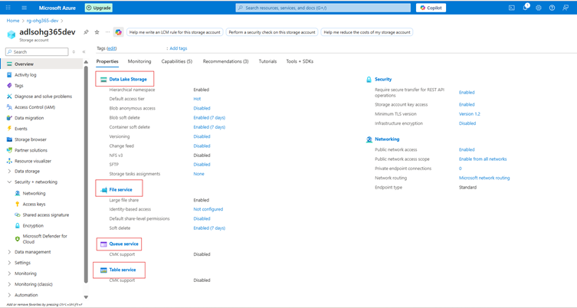

1️⃣ Data Lake Storage
Purpose: Designed to store large volumes of unstructured or semi-structured data such as files, images, videos, logs, and backups.
Key Features:
- Data is stored as Blobs (Binary Large Objects) within containers.
- Ideal for storing large, raw data that doesn’t fit into traditional databases.
- Supports various formats: text, binary, documents, media, and backups.
Common Use Cases:
- Hosting media content like images and videos for websites.
- Long-term storage for backups and archival data.
- Centralized data lake for analytics and big data processing.
- Hosting static websites.
Supported File Types:
.txt, .csv, .json, .xml, .jpg, .mp4, .zip, .bak, and more.

2️⃣ File Service
Used for shared file storage that behaves like a traditional file server.
🔹 Description:
- Provides Azure Files, a fully managed file share in the cloud.
- Uses the SMB (Server Message Block) or NFS (Network File System) protocols the same used by on-premises file servers.
- Can be mounted to Windows, Linux, or macOS systems.
Example Uses:
- Shared network drives for teams
- “Lift and shift” of on-premises file servers
- Application configurations shared across multiple VMs
Example Scenario:
You have multiple virtual machines needing access to the same configuration files. You can store those files in Azure Files and mount them just like a shared folder.

3️⃣ Queue Service
Used for reliable messaging between application components.
🔹 Description:
- Provides asynchronous communication between services using message queues.
- Stores messages in a queue, which can be processed later by background services or workers.
- Ensures messages are delivered at least once and processed in FIFO (First-In, First-Out) order.
Example Uses:
- Sending background jobs (like image processing or email sending)
- Decoupling app components for scalability
- Event-driven architecture
Example Scenario:
A web app uploads an image → sends a message to a queue → a background process picks it up and resizes the image.

4️⃣ Table Service
Used to store large amounts of structured, non-relational data.
🔹 Description:
- Provides NoSQL key-value storage.
- Stores data in tables with entities (rows) and properties (columns).
- Flexible schema you can add or remove columns anytime.
Example Uses:
- Storing user profiles, IoT data, or metadata
- Fast lookups by key
- Lightweight applications needing scalable, cheap storage
Example Scenario:
You have millions of IoT sensors sending temperature data you can store this efficiently in Azure Table Storage.
Service | Type of Data | Description | Example Use Case
Blob Service | Unstructured / Semi-structured | Stores large objects such as files, media, and backups | Images, videos, logs
File Service | File-based | Provides shared file storage via SMB/NFS | Shared drives, application configurations
Queue Service | Messaging | Enables message-based communication between application components | Background tasks, event processing
Table Service | Structured (NoSQL) | Key-value, schema-less table storage | User profiles, IoT data

Explore Datalake Service
Once your storage account is created:
→ Go to your Storage Account
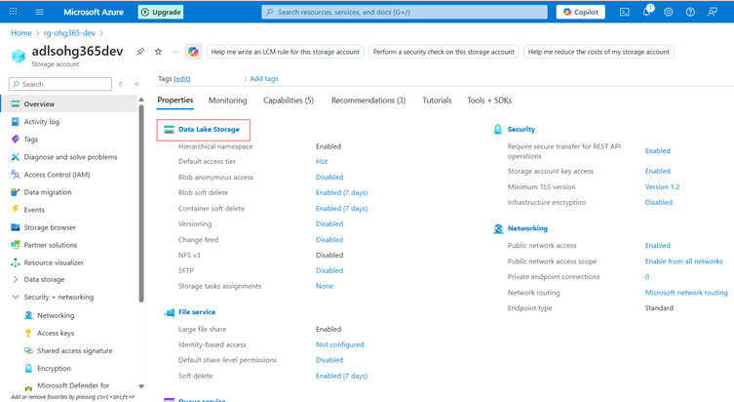

→ Under Data storage, click Containers → This is where your blobs live.
→ Click ➕ Container to create one:
- Name: images, videos, or backups (any name)
- Public access level:
- Private (default) – Only you can access
- Blob (anonymous read) – Anyone with the link can read blobs
- Container (public) – Everyone can see contents

Click on the Add Container button. A new container will open, where you need to enter the container name and then click Create.

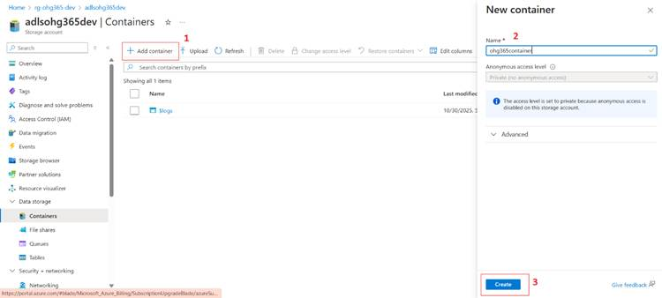

After clicking the Create button, it will be created and added to the items.

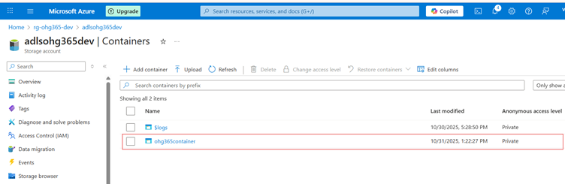

Upload & Manage Blobs
- Click your new container (e.g., images)
- Click Upload
- Choose a file from your computer (like a .jpg, .txt, or .mp4)
- Once uploaded, you can:
- View Properties (size, type, last modified)
- Get the URL to access the file
- Change the access tier

Storage Account
└── DataLake Service
└── Container (like a folder)
└── Blob (the actual file)

→ Click on the add directory button
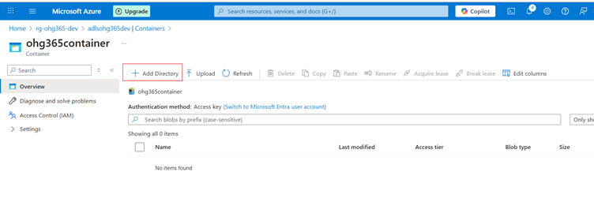

After clicking Add Directory, the directory name will appear at the bottom right. Enter the folder name and then click the Save button.
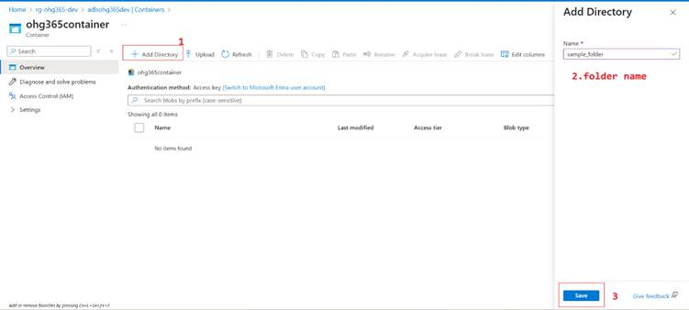

After clicking the Save button, the page you created will appear on the overview page.

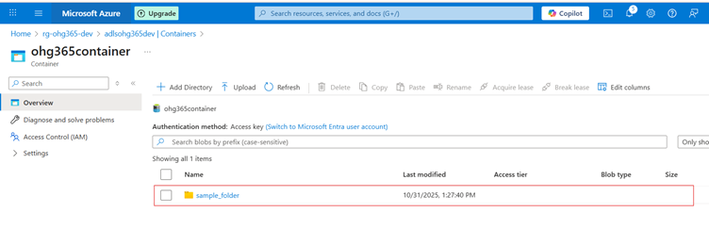

Subfolder:
Click on the Add Directory, the directory name will appear at the bottom right. Enter the folder name and then click the Save button.
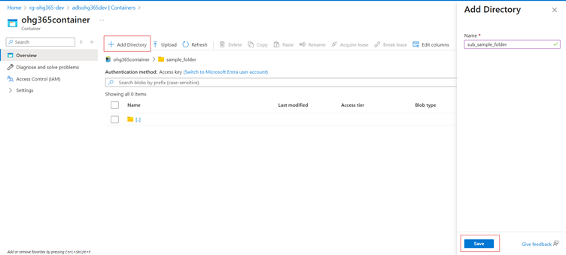

After clicking the Save button, the page you created will appear on the overview page.

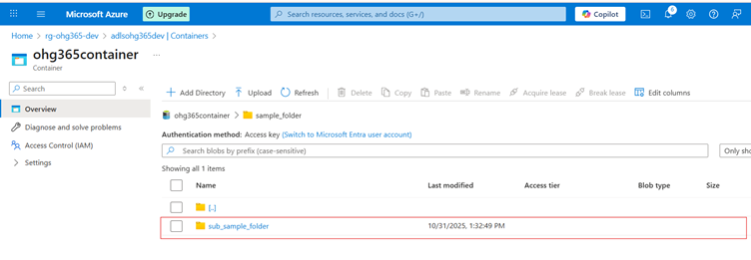

Upload file:
Click on the Upload option here.
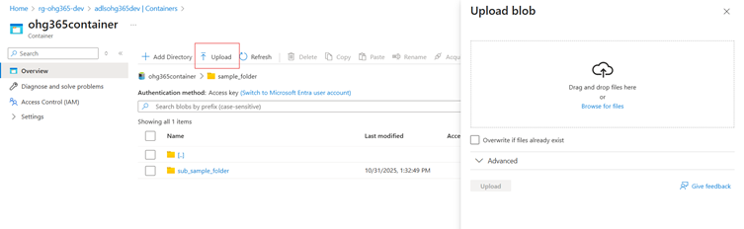

After clicking the Upload option, the Upload panel will appear at the top-right corner. Then click the Browse for files button, Choose the file here, and then click the Open button.

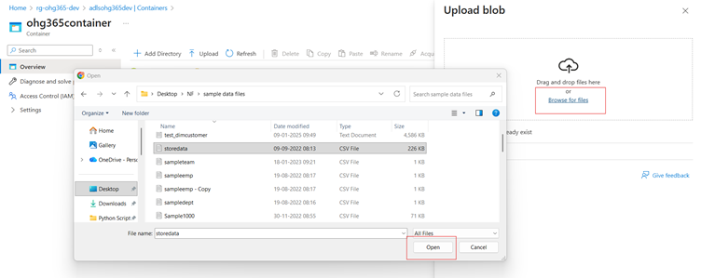

Finally, click on the Upload option here.

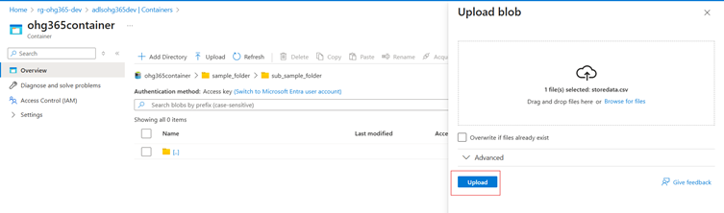

After clicking the Upload option, the file will appear in the list in the Overview page.

